**Lab No :** 01

**Lab Name :** C Program to Swap Two Numbers

**Source Code:**

#include<stdio.h>

int main(){

int temp, num1, num2;

printf("Enter The Value Of: Num1 & Num2 \n");

scanf("%d %d", &num1, &num2);

temp = num1;

num1 = num2;

num2 = temp;

printf("%d \n%d", num1, num2);

}

**Output :**

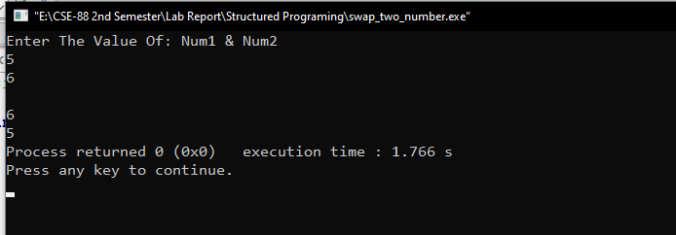

**Lab No :** 02

**Lab Name :** C Program to Check Whether a Number is Even Or Odd

**Source Code:**

#include<stdio.h>

int main(){

int temp, num1, num2;

printf("Enter The Value Of: Num1 & Num2 \n");

scanf("%d %d", &num1, &num2);

temp = num1;

num1 = num2;

num2 = temp;

printf("%d \n%d", num1, num2);

}

**Output :**

